Did you know… There are student loan forgiveness programs and scholarships for math and science teachers.
Federal Student Loan Forgiveness**
Direct Subsidized and Unsubsidized Loans: studentaid.ed.gov/sa/repay-loans/forgiveness-cancellation/teacher
- Up to $17,500 forgiven if you are a highly-qualified math or science teacher in a low-income secondary school after completing 5 consecutive years of teaching
- Can only apply after completion of the 5 years
**Many states and specific school districts offer student loan forgiveness programs in addition to the $17,500 Federal forgiveness.
Perkins Loans***: studentaid.ed.gov/sa/repay-loans/forgiveness-cancellation/perkins
- Need to be teaching in a high-needs area OR low-income school; qualify for deferment while teaching full-time math or science
- 15% forgiven/year Years 1 and 2 (includes interest accrued during the year)
- 20% forgiven/year Years 3 and 4
Remaining 30% forgiven in Year 5 (for 100% loan forgiveness!)
*** New Perkins loans will no be made after 2018; however, the forgiveness program will continue to serve those who have Perkins loans.
Scholarships and Grants
TEACH Grant ($4k/year): studentaid.ed.gov/sa/types/grants-scholarships/teach
Did you know… Teaching jobs have better retirement benefits than most other jobs you can get with the same degree.
Retirement
Colorado schools offer PERA retirement benefits:
- Example: Begin teaching at 22 years old, full retirement benefits at 57
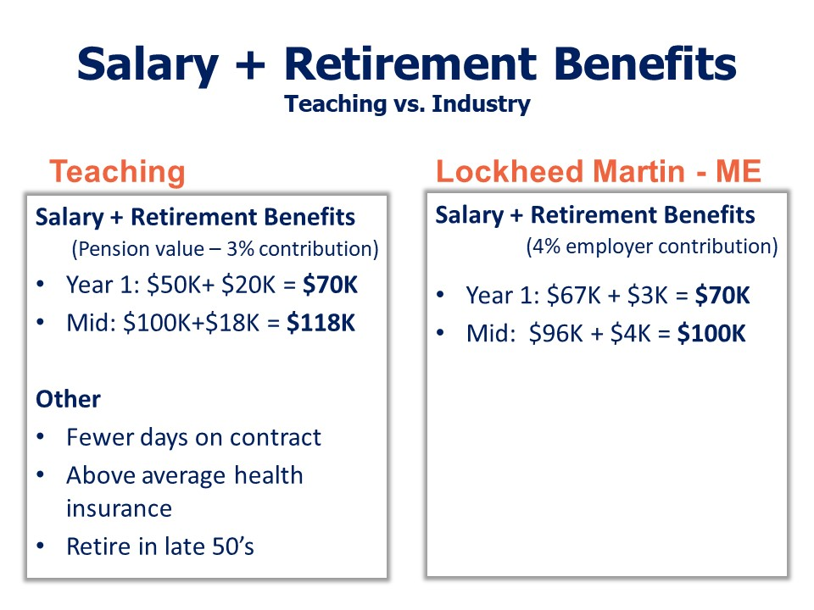
  - 87.5% of highest annual income (e.g. a pension)
  - Yearly Annuity Value of $21,600
Yearly Annuity Value: Someone in industry would have to invest this amount at 7% ROR to have the same available retirement as a teacher’s pension based on average life expectancy, HEI=$100K
Results are based on telephone interviews conducted as part of the Gallup-Healthways Well-Being Index survey with a random sample of 172,286 workers, aged 18 or over, from Jan. 2-Dec. 30, 2012. For results based on the total sample of national adults, one can say with 95% confidence that the maximum margin of sampling error is ±3.5 percentage points for the smallest group (physicians) but less than ±1 for larger groups such as professionals, service workers, or managers/executives. https://news.gallup.com/poll/161516/teachers-love-lives-struggle-workplace.aspx
†Cantril H. The pattern of human concerns. New Brunswick, NJ: Rutgers University Press, 1965.
Q1
Q2
On which step of the ladder would you say you personally feel you stand at this time?
On which step do you think you will stand about five years from now?
The Cantril Self-Anchoring Scale†
Top
Best possible
life (10)
Worst possible
life (0)
Bottom
Middle
7 or greater for Q1
& 8 or greater on Q2
4 or less for Q1 & Q2
Percentage shown is the % of people ranking their lives at the top of the ladder minus the % of people ranking their lives at the bottom of the ladder.
Did you know…
Teachers in the United States rate their lives better than all other occupation groups, trailing only physicians.

