Did you know… There are student loan forgiveness programs and scholarships for math and science teachers.
Federal Student Loan Forgiveness**
Direct Subsidized and Unsubsidized Loans: studentaid.ed.gov/sa/repay-loans/forgiveness-cancellation/teacher
- Up to $17,500 forgiven if you are a highly-qualified math or science teacher in a low-income secondary school after completing 5 consecutive years of teaching
- Can only apply after completion of the 5 years
**Many states and specific school districts offer student loan forgiveness programs in addition to the $17,500 Federal forgiveness.
Perkins Loans***: studentaid.ed.gov/sa/repay-loans/forgiveness-cancellation/perkins
- Need to be teaching in a high-needs area OR low-income school; qualify for deferment while teaching full-time math or science
- 15% forgiven/year Years 1 and 2 (includes interest accrued during the year)
- 20% forgiven/year Years 3 and 4
Remaining 30% forgiven in Year 5 (for 100% loan forgiveness!)
*** New Perkins loans will no be made after 2018; however, the forgiveness program will continue to serve those who have Perkins loans.
Scholarships and Grants
TEACH Grant ($4k/year): studentaid.ed.gov/sa/types/grants-scholarships/teach
Did you know… Teaching jobs have better retirement benefits than most other jobs you can get with the same degree.
Retirement
Colorado Public Schools PERA Retirement Benefits: copera.org/resources/calculators/pera-monthly-retirement-benefit
- Your eligibility for retirement is based on #years teaching + age
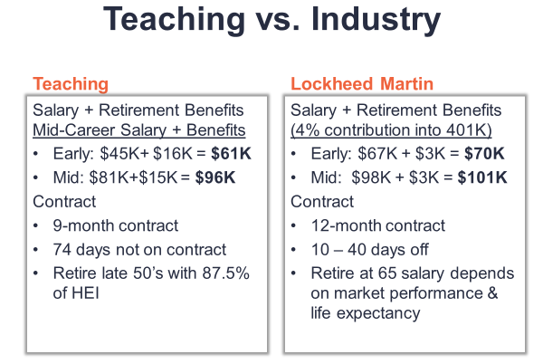
- For example, if you begin teaching when you are 22 years old, you are eligible to retire with full benefits when you are 57. The PERA calculator shows that a person who does this will earn ~87.5% of their highest salary as their pension.

DATA MINING TASK:
1 hour workshop questions:
- Does your institution have scholarships for pre-service teachers?
- Do you advise students about loan forgiveness programs?
Additional questions for longer workshop :
- Does your state have both a pension and social security? (Search “social security offsets” to learn about your state)
- Spend 10 minutes looking up as many of the items in the Retirement chart for your state as you can. If your state is already on the chart, help your neighbor. https://bit.ly/2Z1cF9j
  - https://docs.google.com/spreadsheets/d/1EbQ7wYrRKXULsDIZTwbdinmsIBWOJDylz5ExK_mz_KA/edit?ts=5d27f0d6#gid=460651270
  - If a person retired at 60 years old in your state, use the salary chart for one of the districts to determine their starting pension.
- Look up the health insurance benefits for a teacher in the local district(s) where you students are most likely to get a teaching position. Use the same district(s) that you researched for salaries.

